Name:- Shreya Panda PRN- 25070122181 CSEB-3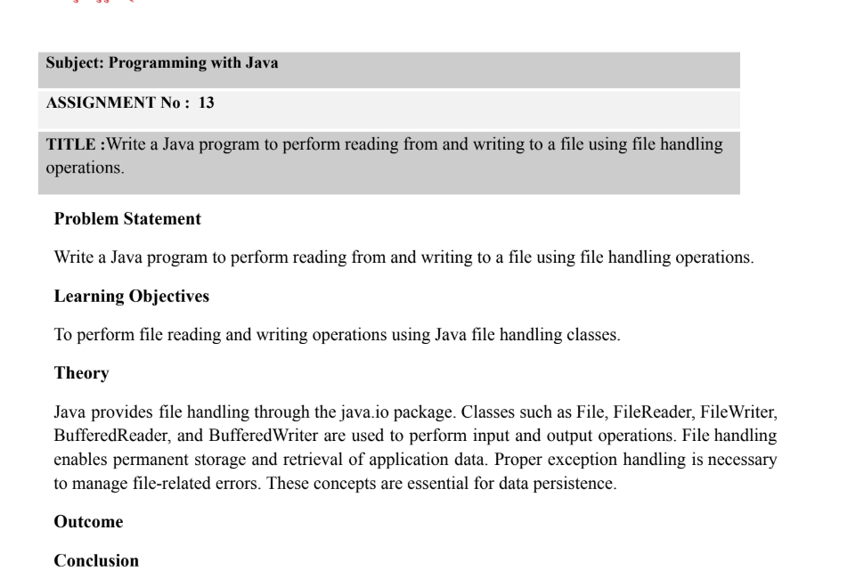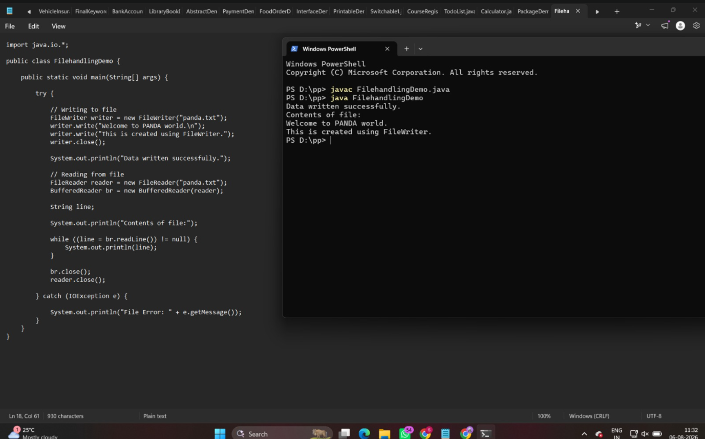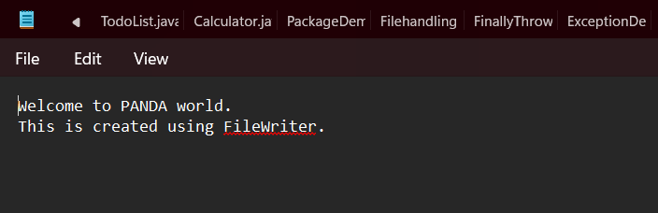

1. Create a program to write and read employee details from a file.

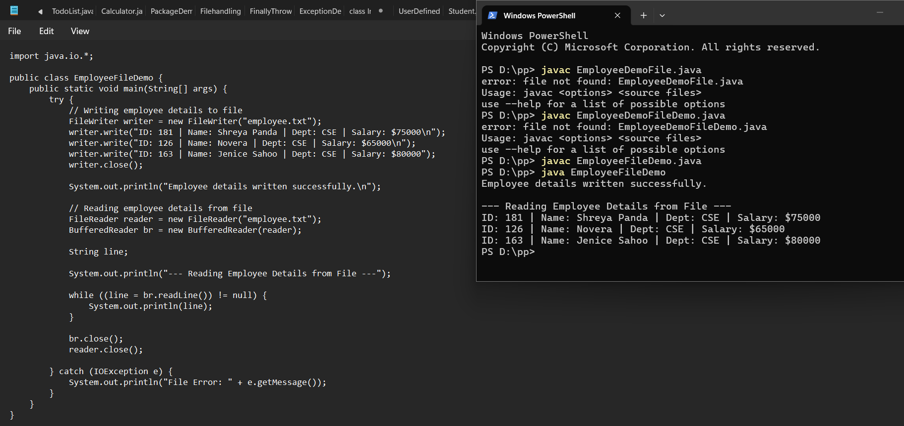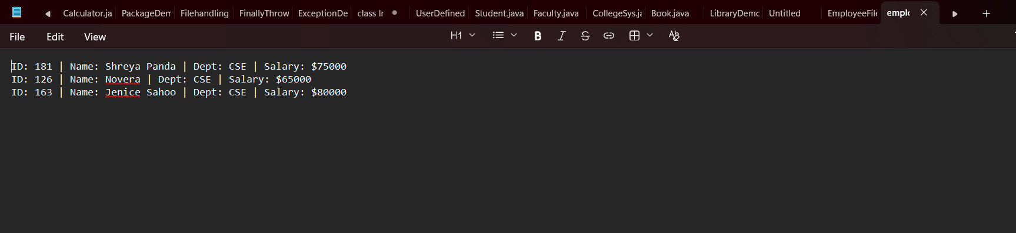

2.Create a Java program to write patient details (patient ID, name, age, and diagnosis) to a file and read the details from the file for display.

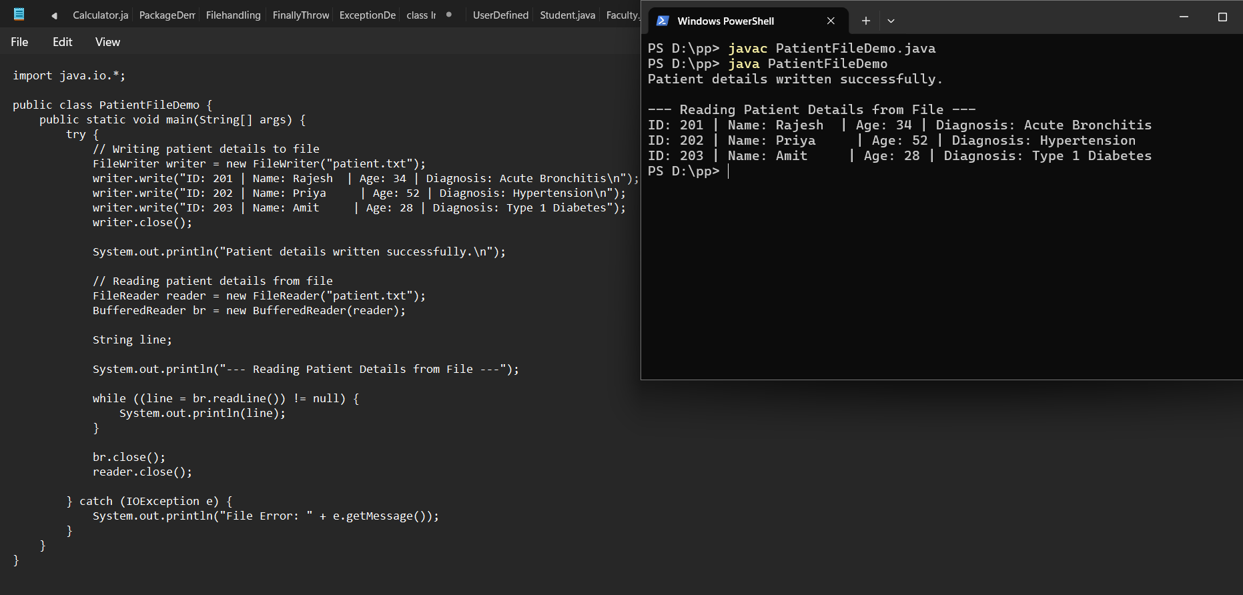
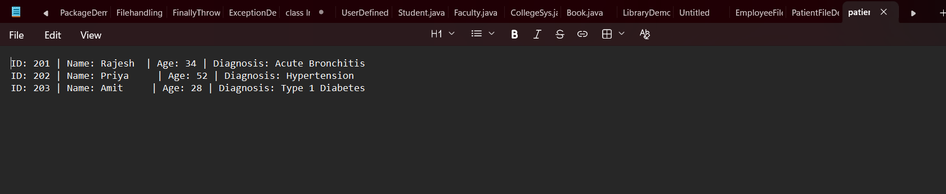
Outcome
- Successfully compiled and executed PatientFileDemo.java to perform file reading and writing operations for patient records.

- Created patient.txt and saved patient details (patient ID, name, age, and diagnosis) using FileWriter, then retrieved and displayed all records on the console using FileReader and BufferedReader.

- Implemented robust exception handling using a try-catch block to manage potential IOException events gracefully during file stream execution.

Conclusion
In this assignment, basic file handling operations in Java were implemented to store and retrieve patient records. Using core classes from the java.io package (FileWriter, FileReader, and BufferedReader) allows Java applications to manage persistent data on disk effectively. Proper stream management and exception handling ensure that file operations execute reliably without data loss or unexpected runtime crashes.

